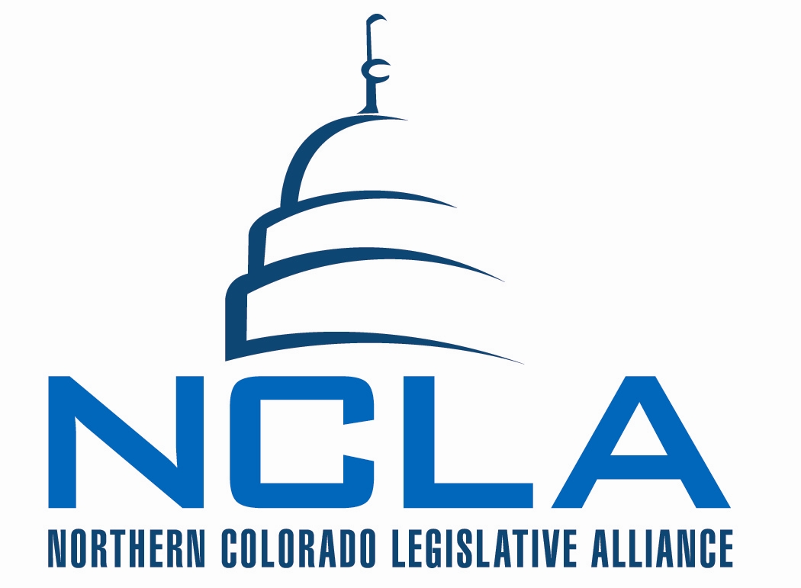
MINUTES – draft

Board of Directors Meeting
February 6, 2014

7:30 a.m. – 9:00 a.m. McKee Conference Center

NCLA Chair – Barbara Koelzer

- Call to Order and Establish Quorum Koelzer
    - Attendance:
      - MacQuiddy, May, McCloughan, Tool, and Gazlay not in attendance.
      - Olson and Norton by conference call.
      - Official attendance tracking recorded on tracking worksheet.

- Presentation
    - Business Personal Property Tax – Representative Young (via conference call)
      - NCLA has make impact that something needs to be done with BPPT - options have opened as state budget recovers. Refundable tax credit (not perfect - but possible option as we move towards addressing this tax dilemma) - local taxing entities (county level and below) that count on the revenue.
      - Businesses still have to file and pay tax. When they file state income tax, they can do paperwork for refundable credit. (backfilling from state level)
      - Thought school districts would be happy- not impacting the property tax. A lot of jockeying around about money lost. See this as a depletion of the general fund.
      - Diane Primavera -cosigning in the house. Williams has signed on the bill. Scheffel will be coming on as one of the Senate sponsors.
      - Bill should be introduced soon.
      - Businesses that are currently exempt will continue to be.

    - Flood Recovery Committee: Senator Renfroe and Representative Young – via conference call
      - Renfroe - thanks for having us. Committee has met several times, taken tours of flood areas. Several bipartisan bills have come out of committee - success so far! Credit goes to how committee was set up - equal Rs and Ds. Working to keep politics away - look at flood and issues.
      - Meeting on 2/14 - to look at a few new pieces of legislation. Hearing a few new issues - contractors not being paid, went to CDOT, was one instance got it taken care of. 95% of all contractors have been paid.
      - Bills dealing with funding issues (timing of money and funds),
      - Young - pleasure working with Renfroe on committee. Appreciate all efforts, good working relationship. Every day discover new issues about this disaster. A lot of work still to be done.
      - Bills - relocating ditch head gates, Sonnenberg took bill to water committee, over 200 water diversions that are damaged as a result of flood. Need to fix so farmers can irrigate in timely fashion. If each case had to go to water court there would be a significant delay. Bill removes requirement to go to water court. Should be heading to Senate.
      - Renfroe - concern coming out of committee, most diversions are private ditch companies, many structures are 100 years old, should these be upgraded as they are replaced, to help in the case of a future flood.
      - Jerke - how can you modernize, while managing concern about field mouse.
        - Renfroe - recently was the first that he'd heard about the mouse.
        - Young - read in the post, caught in situations where existing rules and regulations have a purpose, when encounter a disaster need to be able to act more quickly.
      - Charge of committee - how to be better prepared for future disasters. Putting things back in a better state so we're better prepared for the future - not just head gates, but a number of other pieces of infrastructure.
      - Renfroe - committee is doing a lot of information gathering. Interesting challenge through next few months, there are people who like where the new river is located, some that want it to go back. Huge issue/concern to property owners - farmers and others.
      - Two other bills will probably hear at next meeting. Plans to talk to Governor - concern about debris run off (spring). Should we put a grant together to look at removing debris from the river.
      - “friatifite”(spellying?) growth from flood - spread seed to new areas. (weeds) Steels water from users out of river. How do you manage? Study a mile or two in different patterns - allow growth to occur to see outcomes, also look to see what it would cost to clean up and manage. Environmental groups could have conflict with management.
      - Young - left call for another meeting.
      - Allard - If issue comes up with Preble Mouse, offering expert for testimony (cousin)
      - Renfroe - example shared of checking in with CDOT on how they did the work so fast... skipped regulation checks. They moved forward with fixing without all the checks. Interested in seeing the burden of regulation. How long would it have taken?
        - Norton - offering help... which regulations were skipped.
        - Elish - city of Loveland may be willing to talk about... moving water to get away from their treatment plant (they didn't get permission).
      - Renfroe -(example of COGA sitting on panel) oil and gas was not a contributor to flood damage (in water) it was sewage. Having committee been balanced with equal votes has made for an enjoyable environment to work with.
      - Grant - seems like next year or following, could be fall out. Hope that committee stays engaged.
        - Renfroe - set precedent with wild fire committee. Denver office of Homeland Security has released a letter (November) to all state agencies of a potential Al Qaeda attack on our forests.
      - Example of FEMA dollars distributed - $31,000 to mobile home owner in Evans, $3000 to property owner in Boulder County for a $400,000 home lost.
      - Representative Fisher and Renfroe ran bill to study South Platte (a few years ago) - study just now coming out. Fisher has bill to look at the management of Platte. Overlay with committee as they look at future.
      - Tough questions - was water released to early from Estes? (significant damage above)
      - Renfroe - bills will be controversial to old water holders, city of Greeley will probably have concerns, City of Boulder
      - Renfroe meeting left for Denver.

- Consent Agenda * Koelzer
    - Minutes from Board Meeting – December 19, 2013
    - December Financials
    - MSP to approve consent agenda Allard/Maxey.
      - All support motion.

- Reports & Updates Solin
    - Legislative Update - workers comp issues that we've been monitoring - labor still has not put forth a second draft. Push back is working (NCLA and other business organizations). CAIC not part of push back.

      - Bill Review
        - Bill Consent Agenda
          - HB 1040 – Drug Testing
            - Recommend Support
          - HB 1106 - Tax Deduction for ACA Penalty
            - Recommend Support
          - HB 1231 - Talent and Market Intelligence
            - Recommend Support – moved to monitor.

        - Discussion on Consent agenda: (Solin) three bills recommending support.
          - Drug testing - amps up provisions, makes falsifying a test a misdemeanor.
          - Tax deduction for ACA penalty - (don't expect bill to go anywhere) first time a penalty will be a tax deduction.
            - Allard - a medical cost.
            - Grant - why is it a business issue? (small business)
          - Talent and market intelligence - no fiscal note attached.
            - Berglund and Elish haven't heard about it. Berglund - do not see need for state to fund it.
            - Grant - what is purpose?
            - Elish - find gaps, go to colleges to look at curriculum, Director thinks we need to be talent rich.

        - MSP Lidiak/Bright amend consent agenda - monitor HB 1231.
          - All support amended consent agenda. Motion passes.
        - MSP Allard/ Berglund approve consent agenda as amended.
          - All support. Motion passes.

        - Bills for Board Review and Discussion
*Each bill name/number is an active link to the bill page on Colorado Capitol Watch

BILL CATEGORY – Economic Development

Bill Name* | Description | Reviewed by | NCLA Position
HB 1163 | Enterprise Zone Modification Clarification | Berglund  Elish  Allard | MONITOR

        - HB 1163. Berglund - wanted to cap tax credits a $750,000 company can claim, cap can't exist with way law is interpreted, bill makes cap enforceable. Clean up language they didn't write it right.
          - EDCs - neutral. Reform side has been done. Wait to see what EDDC do on the bill.
          - Recommend moving to agenda for NCLA to take position next meeting.
          - MSP monitor HB 1163 Allard/Waldo
            - All support. Motion passes.

BILL CATEGORY – Water

Bill Name* | Description | Reviewed by | NCLA Position
HB 1026 | Flexible Water Markets Modification Clarification | Jerke  Maxey  Norton | MONITOR

        - HB 1026 - Jerke... amending water law in such a way to allow for "transfers" flexibility on change in use cases.
          - Maxey - two extreme cases, coming out of Aurora - concerns. Concerns in Pueblo. From North Poudre irrigator view point - interested in Ag and Municipal view point.
          - Norton - no major concerns. One person’s flexibility is another person’s harm. (sponsors Fisher and Schwartz)
          - Recommend monitor from Jerke and Maxey
          - MSP to monitor HB 1026 Jerke/Salter
            - All support. Motion passes.

BILL CATEGORY – General Business & other

Bill Name* | Description | Reviewed by | NCLA Position
HB 1001 | Tax Credit for prop destroyed by a natural disaster | Allard  LaBonde  (originally assigned to bill on 1/16) | Monitor (1/16)
SB 5 | Wage Protection Act | Berglund  Becker  Maxey | Oppose
HB 1224 | Service Disabled Small Biz Set aside | Becker  Allard  Lidiak | Neutral
SB 57 | Continue Enhanced UI Benefits | LaBonde  Grant  Williams | Oppose
HB 1075 | UI Deferral | LaBonde  Grant  Williams | Oppose

        - HB 1001 - update from Solin, bill will be rewritten to have the state pay for the property tax, the assessors and treasurer will make decision on who will qualify for allowance, state will refund counties (back fill), still with drafter.
          - Will stay in monitor until we see language

        - SB5 - Wage Protection Act. Was adjusted - CAIC prompted some of the change. A number of items removed. CAIC is neutral. Many chambers opposed. (Denver Metro Chamber, NFIB, CO Restaurant Association)
          - Not business responsibility to get employees final paycheck (Maxey).
          - Becker - concerned it could pass.
          - Solin - we may be able to push it back, heavier lift since CAIC has negotiated.
          - Salter - is this good for business? Support. If bad? We should not.
          - Allard - opens door for employee to take action. Recommends oppose.
          - MSP to oppose Jerke/Allard.
            - All support, motion to oppose passes.

        - Koelzer left meeting - management turned over to Allard.

        - HB 1224 (Becker) - it is El Paso county bill, feel good, minimal burdens, you don't like more regulation, is it that big of deal, NCLA could monitor
          - Lidiak - is there need?
          - Jerke - you don't put this stuff in statute. You don't put goals in statute.
          - See - for federal contracts you currently face this. Not a huge thing type of regulation - it is manageable.
          - Becker - do not go on record opposing this.
          - MSP to take a neutral Becker/La Bonde.
            - Motion passes. NCLA takes neutral position.

        - SB 57 - Unemployment Insurance Benefits. Grant - through 2017, set to expire June of this year. $4 million designated out of general fund, annual reporting section - vacant of content, we opposed a similar bill in 2013, what are the outcomes? Increase in unemployment for business. Recommendation to oppose. Social issue camouflaged as work force development.
          - MSP to oppose SB 57 Grant/Maxey
            - All support motion to oppose.

        - HB 1075 - Unemployment Insurance Benefits. LaBonde - straightforward and not good. Deferral period --- had benefits and accepted work, 10 weeks reduced to the period of time to worked.
          - Melton (Denver metro) - no senate sponsor. Recommend oppose.
          - See - does this reload all of their benefits. (Start over?)
          - MSP to oppose HB 1075 Jerke/LaBonde.
            - All support motion to oppose.

    - Relationship committee - no report.

    - Technology committee - Lidiak

      - Looking into options with Olson for upgrading Loveland capabilities. (web based) Allow guests to “skype” in to meeting.
      - Investment in voter voice- use tool, need to check on database and how current it is. If not used, should NCLA make the investment?
        - How current is database? Some chambers put all members in database, others use “opt in” method.
        - Miller to make sure all board members are in database.
        - Strategies - what do we want to engage in. Wage protection may be one to share with members.
        - Who does message come from? Chambers or NCLA?
        - Fine line of using tool - frequency.
      - Grant – recommends Executive Committee look into Voter Voice use and issues for engagement with investors and members.
      - Website – Miller – getting close to being able to use Board Access pages. Had to reformat as to not allow anyone to become and user and log in as a board member. 75% complete. Still a few areas that need content.
      - Berglund - 5 organizations, who controls messaging? What is the communication policy? Buy in from all organizations. If this is the advocacy arm, all should be unified in messaging.

- Upcoming Meetings & Events Koelzer
    - February 13th - NCLA Executive Committee Meeting – 7:30am Call
    - *February 13th – Legislative UPDATE call – 8:30am
      - *To be confirmed – potential conflict with Solin presenting to Leadership group at the Capitol
    - February 20th - NCLA Board Meeting – Loveland Chamber 7:30am
    - February 27th – Legislative UPDATE call – 8:30am

- Adjournment at 9:05 am by Allard.

2014 NCLA Bill Tracker: http://www.coloradocapitolwatch.com/bill-analysis/537/2014/0/

