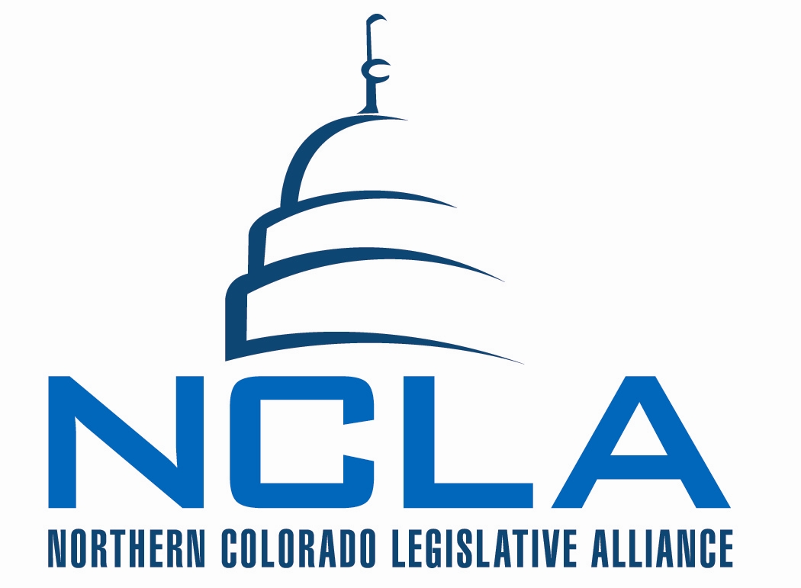
MINUTES - DRAFT

Board of Directors Meeting
March 6, 2014

7:30 a.m. – 9:00 a.m. Loveland Chamber of Commerce

NCLA Chair – Barbara Koelzer

- Meeting called to order and quorum established by Chair Koelzer at 7:30am.
    - Attendance recorded on tracking worksheet.
    - Board members not present: Sharie Grant, Carl Maxey, Steve Tool, Laurel LaBonde, Tambor Williams, Steven Olson, and Carol Salter.
    - No conference call was hosted for the meeting.

- Consent Agenda * Koelzer
    - Minutes from Board Meeting – February 20, 2014
    - MSP to approve consent agenda McCloughan/Waldo.
      - All approve. Motion passes.

- Reports & Updates Solin
    - Legislative
      - Update from Solin
        - Workers comp is still on the table. Williams and labor unions are conspiring They will move forward - no draft bills available yet
        - Angel Investor tax credit bill has a long way to go due to fiscal implications.
        - Testifying today in support of BPPT bill in finance committee. Will share that it does not go far enough. SB 42 - bill builds upon legislation last year (incentive agreements).
        - Will be involved in CAIC rally today. Will speak if asked "go business" - "go northern Colorado"

- Board Discussion – I25 North Koelzer/Solin
  - Koelzer - Thanks to those who joined the elected official’s coalition. Learned something new about RAMP grant. CDOT announced that the proposal to toll 3rd lane is not viable. Working with consultants to figure out next steps.
  - Elected officials agreed to ask for an extension to RAMP grant. (current deadline April 7th) NCLA will be asked to write letter as well.
  - How was it determined it was not viable?
    - Not enough traffic volume to great needed revenue.
  - CDOT admitted the idea of tolling a lane to build additional lanes may not be viable. Tolls would pay for operation and maintenance not construction.
  - Norton - there is a way to toll and get a benefit. The capital or maintenance can be used. Three pots of money to recover (finance, OM, capital). If all placed on tolling makes it a high toll. This would drive people off the tolled road. You have to subsidize the finance, OM or capital. CDOT’s present budget will not even maintain the lanes we have. They cannot toll an existing lane. When analyzed what you could toll it was not enough.
  - Koelzer -- elected officials agree to continue to ask for federal funding. Congressional delegation should know this a priority!
  - Allard - comments were made about funds being used for improvements on the south rather than the north
  - Koelzer- P3s no longer willing to put money in to fund. (public private partnership)
  - Solin - working to learn more over the last three weeks. $90 million is focused beneath (south of) HW66. Concerned about no funds between HW66 and HW14. We need to continue to ask for federal funds and authorization. Encouraged by conversations that are happening with delegation. Fear with RAMP is that we may forgo future opportunities should the P3 program not work. (more consistent funding) Concern of fracturing in the region! Opportunity to rebuild the relationships. CDOT is adamant about RAMP. We have a job to bring forth a unified front.
  - Becker - did HW 36 come up?
    - Koelzer - The "silly" sunshine group took their time and were not able to focus on the RAMP program and delayed their availability to work on the I25 project.
  - Interest in resending support for RAMP. (number of board members)
  - RAMP and federal dollars are not mutually exclusive. What good would it do?
  - Allard - thinks Weld Co Commissioners presentation and stance makes sense. Question is how do we get money to pay for it? We need to figure it out and stand together.
  - Norton - we should not oppose any method of getting funding! Support full force. In the order of funds available - RAMP is #1 in terms of available funds. Local participation to the degree that local communities are willing to participate to add leverage. A piece of tolling at a high volume area. (south) Traffic has to be an F class to pay for a toll (not moving). Think in terms in New York or California. We need all sources! Local governments will have to put funds in. Last possibility is funds from federal government. Trust fund in broken. Money has not been added to trust fund for 20 years. 100% has been utilized and borrowed from the general fund. (Timing in a political year - not going to happen)
  - Koelzer - Do local governments have money to put in?
  - Norton - If we look at it from Economic Development future. Have to be careful how you do that! Local governments have been hesitant to participate in combined projects. If we want to grow we'll have to invest in transportation.
  - Berglund - appreciate pushback from Weld County Commissioners. (others have same perspective) Nothing North of HW 66 is on the table at this point. CDOT story keeps changing; mantra is "trust us". Challenge that "trust us" plan is hard to get behind when you don't know the plan. You have to do something. Tired of rhetoric and lack of vision and leadership. We as business leaders will have to figure outside of political process and make political come with us.
  - Norton - CDOT has been forth coming. We have to support CDOT! People are not going to put money in if they will not get a return.
  - Elish – positive outcome from last night was the coalition writing letter to support delay decision. (federal funds long short) Important to look at all sources of funding. In this election year, people will not let one politician "look good".
  - Barbara Kirkmeyer was running for Congress last night.
  - Elish - This effort needs to be run by the business committee. (Richardson, Gendron, Walmart distribution center and those from Weld County) Business community had success in Northern Maine.
    - Koelzer - figure out a way to get them at the table. Business community made impact last night.
  - Gazlay - Frustrated last night at meeting. NCLA put I25 as priority at 2014 retreat. Had a conversation with Sean Conway after the meeting. Greeley and Longmont missing (200,000 people). We need to press issue. Need someone effective from Loveland City Council at the table. Appreciate that congressional delegation involved. (amazing they don't know how bad the problem is)
  - Koelzer - no Larimer County Commissioners attended.
  - Polis representative announced meeting March 19th at 7:45am - roundtable to discuss transportation. (Loveland Chamber)
  - Gazlay – Action plan – hire a PR firm? Billboard on I25? We need to spend money being the squeaky wheel. Curious to see what it would cost to create (facility) somebody could underwrite. CDOT will not share data that shows investment.
  - Allard - Gardner announced for Senate. Authority in House lost. Rule about getting involved in coalition.
  - Norton - have to be on the corridor to have an opinion on tolling lane. Those on the lane agreed they didn't want it.
  - NCLA could talk with and work CDOT. If they come out and be a leader they get nailed to the wall. Everything is their fault. They need a leader that has enough ideas. (Example from TREX project - 5 investment bankers). More complicated than 'it's just a road'. We need to get the leadership and ask the right questions. They are willing to build, finance and maintain. They can't do the politics -- beyond their capability.
  - Gazlay - frustration with "the emperor has no clothes" How does CDOT representative not have the data? Let's find a solution to this! Everyone is looking for power and creating their kingdom.
    - Norton - he can't answer. When he answered in the past people cut 'the legs out beneath' him. If he answers like that - the politics in the room was confusing. He'll lose regardless how he answers.
    - Berglund - tone changed
    - 2/3 funding of RAMP goes south of HW 7. Remaining 1/3 is nothing. (where the hurdle is)
  - Solin - conversation is productive and helpful. Business community needs to lead on this. Very concerned about what we're hearing about viability of tolling north. Feels like talking about a train. "It'll never happen because of the numbers". Understand what we want to achieve - how to we in a unified way as a business community get that done. If we aren't clear on how we get there - we will not get the response we need. History of Northern Colorado (NCLA) - been talking about this for 20 years. Region has played nice with CDOT. We're at a point where we need to take gloves off and looking at solutions. Understand federal dollars are difficult. Engage legislators and congressional members. Think it is imperative we engage and business community leads! We have to provide opportunities and alternatives. Bringing in a banker. Convene meetings with business leaders.
  - May - time resources biggest concern, money set aside for this issue.
  - Solin - what would we support in terms of a solution? We need to do fact gathering so we can understand options.
  - Norton - what we probably need first is to get a project manager to come and talk about major issues. (Kiewit) CDOT is good on maintenance and construction. They (CDOT) are buried in terms of their own politics. How does it work and what questions need to be answered. Take information and get business group together to understand options. Ask where is the participation? Where do you want to go from here?
    - May - we need a project manager.
  - MacQuiddy - such a valuable discussion. We've become wiser. Would recommend hitting pause today. When is the next meeting we can discuss this. Greeley wants to be at the table. Exciting opportunity! Look at meeting schedule to designate a time for continuing the conversation. Three Execs need to get together to discuss resources.
  - May - action needed today... letter to Transportation Commission supporting the extension of the RAMP funding application.
  - Elish - make it an economic development issue! Not about numbers but about economic development.
  - Solin - all options need to be on the table.
  - May - general position on I25 but we don't have a strategy. End product is a strategic framework and plan for next decade. (RAMP or what's going on in congress) Start to drive this issue! Long term plan in place.
  - Elish - Shaffer working to arrange meeting with south Denver transportation group. Elish has asked to be a part of the meeting.

  - MSP to send letter to transportation commission (RAMP Grant) MacQuiddy/Allard.
    - All Support.

  - MSP to support and write letters to congressional leaders Norton/Gazlay
    - All support.

  - MacQuiddy - look at meeting time. Dedicate an upcoming meeting.

- Bills for Board Review and Discussion
*Each bill name/number is an active link to the bill page on Colorado Capitol Watch

BILL REVIEW

Bill Name* | Description | Reviewed by | NCLA Position
HB14-1297 | Analyze Health Data Regarding Front Range Oil Gas | Jerke  Norton  Berglund | Oppose
HB14-1292 | The Student Success Act | Lidiak  Williams  Gazlay | Monitor – actively
HB14-1287 | BEST Moneys For Disaster Damaged Public Schools | See  Waldo  Becker | Monitor
SB14-147 | Increased Well Pumping Study South Platte River | Allard  MacQuiddy | Support
HB14-1278 | Sunset Work Comp Physician Accreditation Program | Salter  May  McCloughan | Support

- Bill Review and Discussion:
  - HB 1297 - Jerek - analysis of human health and quality of life. No reason for this bill.
    - Solin - not too different from bill we opposed last year. (we killed this bill last year) Norton testified against it last year. Part of regulatory process anyway. Waste of money. Information is there and available and can be received without a bill (use a resolution).
    - MSP to oppose Jerek/Waldo
      - All support motion.

  - HB 1292 - Lidiak - new education bill to try to help further reform around last year's SB 213. $1.3 billion surplus in education fund. Legislation is still trying to figure out what to do with education fund. Want to propel ideas on education reform. School community looking at legislation - dollars coming from the state with a lot of strings attached. SB 191 will go in to affect this next year. If you look at this bill, it has broken out and put controls on dollars. It does bring bipartisan support. (nice to see compared to last year) We support investment in education find it distasteful (hope for amendments) the regulation included. (lacks local control) $260 million fiscal note, $155 recurring. Buy down negative factor by $100 million. One time funds to access with reform efforts ($40 million) to help with implementation. Includes funds for capital construction. Think bill has great general support, recommendation to actively monitor the bill. Advocate for not as much control.
    - Gazlay - 11 page fiscal note, we need to find a way to support education. Concern over cap of negative factor. Appears to be a "Christmas tree bill". Curious to see what comes out of committee. Concern local school districts can't decide what is best for their school districts. 21 new state employees create - more bureaucracy. Need to support with those caveats.
    - Solin - in committee earlier this week. How is this different than Amend 66?
    - Lidiak - It also had a lot of control. School boards supported 66 but wanted less control. Comments about negative factor.
    - Solin - negative factor is difference between where school districts were before the negative session and__?___.
    - MSP to monitor actively (do not let them Christmas tree this thing) Lidiak/Gazlay.
      - Comments - Solin C3 and CAIC have not taken position.
      - Solin - can put it back next meeting for further board review and discussion.
      - Norton - Would like to know if there is anything that adjusts the distribution (formal for distribution) Is school district getting the same as last year? If they are adjusting the "who gets what". Would like to see us develop an amendment. If you're putting money back let school districts decide how to spend it.
      - Call for vote on motion to monitor.
        - All support.

  - SB 147 - Allard will recommend support. Establishes baseline. You can't do much until you have a study.
    - MSP to support Allard/Becker.
      - Norton opposes motion.
      - Motion passes.
      - Comment from Norton - court will make final decision anyway. It stirs pot in negative way.

  - HB 1287 - Becker - funds emergency construction of schools damaged in disaster. Uses funds from marijuana tax. Recommendation to monitor. Was it intended forever? ($40M for ever)
    - Solin - funds towards school construction, directs priority for disasters.
    - MSP to monitor Becker/Waldo
      - All support

  - HB 1278 - May - wish Salter was here to share insight. Did not understand why it was on our list. Continues program for 11 years, directs whether CO should adopt some guidelines.
    - Norton - we should support, run when sunset comes up. Necessary to have national accreditation program, without reverts to state judicial system. Nothing negative. (continuation of sunset and accreditation)
    - MSP to support Norton/Jerke.
      - All support.

- No Committee reports.

- Upcoming Meetings & Events Koelzer
    - March 13th – NCLA Executive Committee Conference Call – 7:30am
    - March 13th – Legislative UPDATE call – 8:30am
    - March 20th - NCLA Board Meeting – Loveland Chamber 7:30am
    - March 27th – Legislative UPDATE call – 8:30am
    - April 3^{rd -} NCLA Board Meeting – Loveland Chamber 7:30am
    - April 10th - NCLA Executive Committee Conference Call – 7:30am
    - April 10th - Legislative UPDATE call – 8:30am
    - April 17^{th-} NCLA Board Meeting – Loveland Chamber 7:30am
    - April 24th - Legislative UPDATE call – 8:30am

- Adjournment at 9 AM by Chair Koelzer.

2014 NCLA Bill Tracker: http://www.coloradocapitolwatch.com/bill-analysis/537/2014/0/

