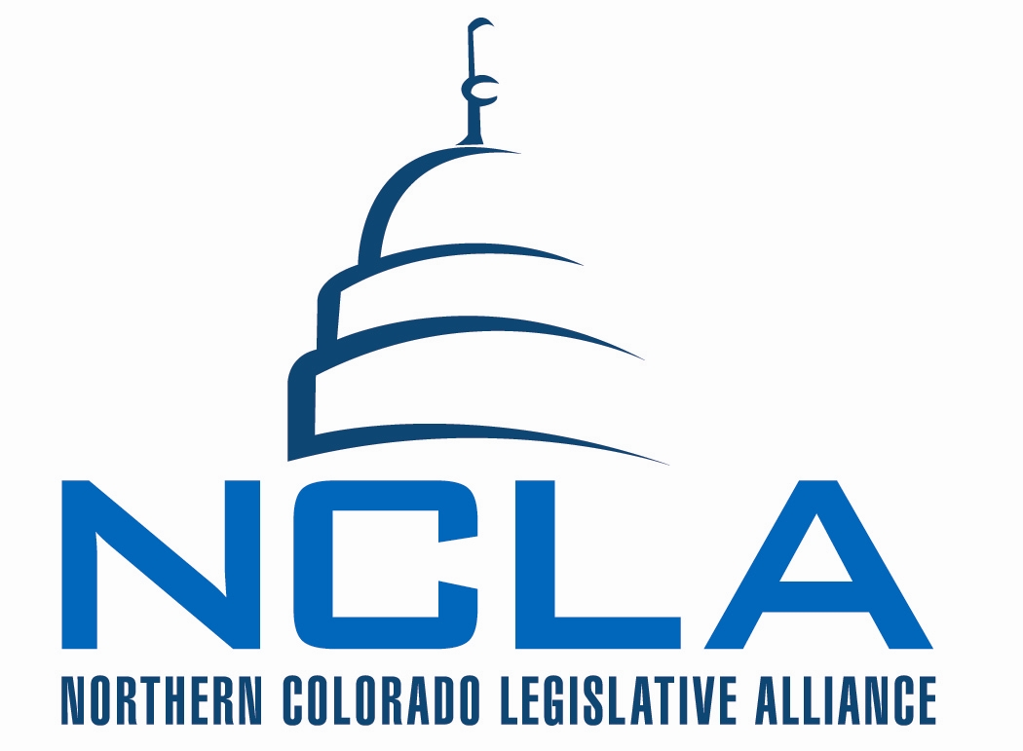
MINUTES - draft

Board of Directors Meeting
March 17, 2016

7:30 a.m. – 9:00 a.m. Loveland Chamber of Commerce

NCLA Vice Chair – Bill Becker

- Meeting called to order and quorum established by Vice Chair Becker at 7:35am.
  - Quorum established at start of meeting.
  - Board attendance recorded on tracking worksheet.
  - Guests –
    - Amy Dugan, Greeley Chamber of Commerce.

Name | March 17, 2016 | Total attended in 2016 | Total absent in 2016
May | x | 4 | 1
Allard | x | 5
Grant | Not present | 4 | 1
Maxey | Not present | 1 | 4
Tool | x | 5
Waldo | x | 4 | 1
MacQuiddy | Not present | 3 | 2
Bright | x | 4 | 1
Dennie | x | 3 | 2
Jerke | x | 5
LaBonde | Not present |  | 5
Norton | Not present | 4 | 1
Williams | x | 5
McCloughan | x | 3 | 2
Becker | x | 4 | 1
Clark | Not present | 3 | 2
Gazlay | x | 5
Koelzer | x | 5
McCambridge | x | 3 | 2
Olson | x | 5
Werner | Not present | 3 | 2
Solin | x | 5
Miller | x | 5

- Consent Agenda
  - Minutes from March 3rd board meeting
  - MSP Tool/Koelzer to support.
    - All Support. Motion passes

- Reports –
  - Financial – Allard and McCloughan
    - $2500 in the account
    - Bills paid
    - $5900 in receivables
    - $31,000 in I25 account
    - Becker – no update yet from NCEA on level of participation and financial commitment.
  - Legislative update- Solin

- Discussion – Transportation, Fix North I25
  - May – Tool, May, Koelzer and Solin attended meeting last week with CDOT officials, county officials. They put on the table a proposal that they are serious about to put down two lanes in the median from HW 14 to south of 402. Cost is $230M. If they get those dollars they would do the project within the next three years.
      - $80 from SB228
      - $100 from low interest loan
      - Local contributions
      - $25M from federal TIGER grant
    - Concern raised with the group was this is great solution but doesn’t address the complete $1.2B problem.
    - Tool – they are defining this as phase one of big project. This has to be done anyway to create detour lanes for major project.
    - Gazlay – bridges included?
      - Poudre Bridge and railroad bridges.
    - Media partner trades. Solin working with PR/Marketing team on communication pieces.
  - Talking to groups. Leadership Northern Colorado next week. Lots of requests.
  - Budget announced tomorrow – will affect so much!
  - McCloughan: Partnerships – three CEOs met. May will be reaching out to Windsor Chamber to work with I25 efforts.
  - Fix CO Roads – issue is not going away, we continue to build state wide business network to work on chipping away on larger transportation issue
  - Allard – have we seen the results of Contractors survey?
    - Solin – new pollster last week. They’ll report tomorrow on results. Solin will attend and invite other committee members.
    - Initial polling they believed they could get 57% in favor of 3/4cent sales tax. They were testing other rates.
    - There is other polling that indicated they couldn’t achieve more than 50%
  - Solin – we have our own polling in the field (yesterday). There will be four polls that will talk about sales tax. Taxes are generally difficult to pass. You should have close to 60% in favor before you get started. That will help overall in assessing. Important for us to understand, contractors have asked that we make our deal contingent on passing of their deal. They can’t promise big projects. (fewer dollars annually) They can’t promise a billion dollar project. Bonding becomes an important piece of their equation. We don’t need a tax increase to get the $3.5Billion. We would be reluctant to be contingent upon their passing.
    - Tool – they would create a permanent stream of funding, spreading out construction. Bonding front loads projects. They are trying to guarantee work forever. Very different agenda than ours.
    - Solin – believe there is a way to weave them together without being dependent on one another. Will have a conversation on if it is possible to create more bonding capacity? (like a mortgage, approved for a set amount)
    - Tool – is it fair to say that for them the bond issue isn’t important?
      - Solin – we all want money for transportation?
    - Gazlay – will theirs be a constitutional change?
      - Solin – dollars would go to HUTF (specific)
      - They are looking at total revenue of $600M total annually. Flows into HUTF, it then goes 60% state and 40% for local governments.
      - Solin – it is a constitutional change.
    - Jerke – was unaware about two lanes in median, billion dollar savings. There is that to think about. Need to be thoughtful about it! Represent people that will not support giving more dollars to government. Recognize that a 2cent sales increase in CO would still not cover some of the big projects CDOT wants to build. (example I70) Big tax questions would be hard to pass.
    - May – I think where we are in this conversation is no linkage.
      - Tool – they have a very different agenda.
      - May – Jerke has raised good points. Would be good to refrain what we are trying to get done this sessions.
  - Solin - $3.5B program (TRANS) continue existing program, move forward with program, and identify funding with some dollars from general funds and dollars from CDOT. Total payment $350M annually. 228 was a promise of funds for 5 year period, formulas that were necessary to move dollars into transportation. 2015 was the first time that began to happen. Anticipating that the billion dollar promise, best we can hope for is $350M at the end of the time allocated. We are looking for permanent source of funds for transportation.
    - Joint Budget Committee has a memo that advising them that there is a path that 228 is problematic. They have been working through bringing forward funds for $100M. (dollars are there)
    - We have overlay of Hospital Provider Fee. The debate has created a situation that Speaker and Governor have said you won’t get dollars unless we get Hospital Provider Fee. Pleased that Senate Republicans didn’t react immediately. They have still not closed the door on negotiations. Hullinghorse has discussed being willing to distribute refund of dollars to voters.
    - The good news is there seems to be willingness to have conversations. Budget forecast comes out Friday. JBC will fill in blank for how much they can do for transportation. (Expect $100M) Dominos begin to fall tomorrow.
      - Hospital Provider fee to enterprise account.
      - Republicans drop bill that $100M to transportation (general fund allocation)
      - Everyone agrees that bonding is a good thing. All agree it’s a good thing once funds are identified.
    - May – 7 weeks left in the session. Moving into activation phase. Renewed Voter Voice. Have tools in place.
      - Thanks to board members for participating in efforts. Many board members active and present by attending meetings.
      - Denver Business Post had an editorial about “nothing has happened this session” – sets the stage that they haven’t done much on transportation. Pressure is there.
    - Tool – make sure everyone saw piece from Kefalas about Berthoud hill climbing lane. Should being this spring.
    - Gazlay – what is strategy at event next week?
    - Allard – what is our bill?
      - Solin – the finance piece of the equation. TRANS. And some of the funding stuff is owned by others, we are helping to push those along.
    - Debrucing measure – meeting later this morning. Proposal to debruce existing revenues for 10 year period. No less than 35% to transportation, 35% for education (p-16) balance for social services (mental health). We will know later this morning on anticipated revenues. That will make clear how much goes to transportation. Reminder than 35% than splits between state 60%/40%. Polling 60% or better to debruce measure.
      - At that meeting (11:30) May and Becker participating with Solin. Primarily about getting information.
      - Will not include other updates on Build a Better CO efforts (ballot reform)
    - Gazlay – question on polling, cell phones and land lines?
      - Solin – 700 in our group, some cell. All registered voters.
      - Solin – will resend polling questions.
    - Becker – if numbers are right over 90% of debrucing efforts locally have passed. Intent to debruce has history of passing.
      - Bright – Greeley will have something on the ballot to debruce finally. D6 one of the only not to be debruced.
    - Solin – motor carriers have proposal to change ownership tax. Could generate $150M after year 6. Wish Carl Maxey was here to discuss. It is complicated, but in the mix as well.

- BILL Review
2016 NCLA Legislative Tracking Report.
Water
- HB16-1313 Auth Local Gov Master Plan Include Water Plan Goal
- NCLA Bill Review: Maxey, Williams, Clark, Jerke
- Discussion
  - Jerke – not that bad of bill, seemed permissive.
  - Includes goals state water plan.
  - No flags on this one from Solin.
  - McCloughan – any unintended consequences?
  - Jerke – recommend monitor.
- MSP to monitor Jerke/Williams.
  - All support motion.
NCLA Position: MONITOR
Energy
- HB16-1310 Operators Liable For Oil And Gas Operations
- NCLA Bill Review: MacQuiddy, Jerke, Allard, Olson
- Discussion
  - Allard – trying to make oil companies responsible for any damage from industry, such as earth quakes.
  - Bad bill.
  - Bright – article about seismic activity in Oklahoma.
- MSP to oppose Allard/Olson.
  - All support motion.
NCLA Position: Oppose.
- HB16-1355 Affirm Local Gov Siting Auth Oil & Gas Facilities
- NCLA Bill Review: MacQuiddy, Jerke, Allard, Olson
- Discussion
  - Koelzer – another awesome bill.
  - Jerke – gets in to authority of regulating oil and gas. Switch from state to locals. Four democrat sponsors outside of Weld.
- MSP to oppose Allard/Olson
  - All support motion.
NCLA Position: OPPOSE.
Health Care
- HB16-1336 Study Single Geographic Area Individual Hlth Plans
- NCLA Bill Review: Dennie, Bright, Gazlay, Grant
- Discussion
  - Dennie – currently insurance companies set pricing in geographic areas, this requires same rate for every area. They do have a cost of business that is different. Example – Kaiser has lower rate in Northern Colorado, based on relationship with Banner.
  - Gazlay – think we should oppose. Company has different rates in communities served. Seems like a bad bill. It is redistribution of costs.
  - Bright – as historical perspective, when community rated as a small business. Costs went up when it was risk and geographic rated. State wide rates help rural areas. Conflicted about bill. Concerns about rural areas of state. Would like to know more. There is a republican on the bill.
  - Dennie – can see point about rural perspective. If the carries are setting rates on cost of doing business in those areas.
  - Gazlay – the answer isn’t then to force people to pay for those rural services.
  - Williams – question – seems that more and more we have a larger % of population on medicade and medicare. Doesn’t it equalize it already?
    - Dennie – not sure that it does. Larger of portion of those on medicare and medicade are on urban areas anyway.
    - Tool – not sure
  - Monitor until we see fiscal note
  - Solin – sponsors are all mountain community representatives. Rates up there are much higher than urban areas. (double) This is a way to level playing field. Driven by mountain/resort areas.
  - Gazlay – so should we subsidize grocery and gas there too? You make a lifestyle choice to live there. Should we support that.
  - Bright – not just mountain, includes eastern Colorado too.
  - Williams – risk is that insurance companies leave state. Will wait for fiscal note but will still probably oppose.
- MSP to monitor Gazlay/Dennie until we see a fiscal note.
  - All support motion.
NCLA Position: MONITOR.
Workforce Bills – Monitored 3/3/16
Additional Review by NCLA Workers Committee (Allard)
- Review from Workforce team… presented by Allard.
  - Will present recommendations based on committee discussion.
  - MSP Allard/Tool to take positions as presented by the workforce committee, excluding HB1301.
    - Discussion on last item (career pathway). Young is a sponsor.
    - Call for vote.
    - All support motion.

- Computer science and digital literacy HB 16-1291 (Lontine & Duran/Hill & Johnston)
NCLA Bill Review: Bright, Williams, Grant
Recommend oppose (no fiscal note yet)
NCLA Position: monitor as of 3/3/16
- Incentives for student success HB16-1289 (Esgar & Duran/Crowder & Garcia)
NCLA Bill Review: McCloughan, Tool, Koelzer
Recommend monitor
NCLA Position: monitor as of 3/3/16
- Apprenticeship study HB16-1287 (Rosenthal & Wilson/Cooke & Kefalas)
NCLA Bill Review: Clark, Werner, Gazlay
Recommend monitor based on legislators
NCLA Position: monitor as of 3/3/16
- Extension of ReHire Colorado HB16-1290 (Esgar & Kraft-Tharp/Hill & Heath)
NCLA Bill Review: Becker, Waldo, Allard
Recommend oppose - $3.6M in 2017, ReHire Colorado (2009 program). Solin not a dead bill on Senate side (Hill sponsor).
NCLA Position: monitor as of 3/3/16
- Tax credit for apprenticeships HB 16-1301(Garnett/Scheffel)
NCLA Bill Review: Allard, Olson, Tool
Recommending monitor. Fiscal note of $79,000. Tool – also reduces General Fund dollars. Picks winners and loser. Suggest pull to discuss later. Hold for now. Committee will review further. Solin will check in with Scheffel. Questions about the bill and winners/losers.
NCLA Position: monitor as of 3/3/16
- Colorado Workforce Innovation and Opportunity Act HB 16-1302 (Duran & DelGrosso/Newell)
NCLA Bill Review: Tool, Werner, McCambridge
Recommend support.
NCLA Position: monitor as of 3/3/16
- Aligning student academic plans with career pathways SB16-079 (Martinez Humenik & Todd/Young)
NCLA Bill Review: Norton, MacQuiddy, Grant
Recommend support. Fiscal note zero.
NCLA Position: monitor as of 3/3/16

- UPDATES
  - Regional Economic Working Teams
    - Workers – no additional comments
    - Water – question on updates to website, current as to what was received by Grant. Tool will check on language.
      - Meeting where zero Colorado issues were addressed. NISP was brought up by Becker. Interesting on panel. (two sociologist, emphasis on getting people to talk to each other) Talked about Department of Interior and how engineers don’t communicate.
    - Energy – Jerke, Greeley had oil and gas on trial. Proposal on 22 well site in west Greeley, passed 5-2. Planning commission oppose 6-0. Elderly opposed. Industry supported. It was a big deal. If had lost in Greeley, would have been big challenge.
      - Tool – what’s happening to revenues? County and city?
        - Jerke – don’t care much about government. (they leave with it) You get money about two years late. Still relying on 2014 production and prices. With 2015 having bad prices, production is up.
        - Becker – are there thoughtful plans for revenue decline?
          - Jerke – Weld has revenue put away.
          - Dugan – they are prepared, adjusting accordingly.
          - Jerke – now in a different world, more like agriculture has been forever.

  - Events Updates
    - Dinner in Denver
      - Contract in place with Palette’s at Denver Art Museum.
      - Cost per person at $60. NCLA to host legislators.
      - Cash bar. No ATM on site.
        - Ice tea, soda, coffee and water hosted.
      - Legislators Ginal, Arndt, Cooke, Kefalas, Lundberg, Delgrosso (probably), Buck
        - Haven’t heard from Humphrey, Young, Saine
      - Program Solin will work MacQuiddy on program.
      - Confirmed for 30 guests.
  - Relationship Updates
    - Staying in front of legislators.

- Upcoming meetings and Events.
  - March 23rd – Dinner in Denver
  - *March 31st - NCLA Board Meeting -Loveland Chamber 7:30am
  - April 7- NCLA Board Meeting -Loveland Chamber 7:30am
  - April 14- Exec Committee 7:30am
  - April 14 – Legislative Update Call 8:30am
  - April 21- NCLA Board Meeting -Loveland Chamber 7:30am
  - April 28 - Legislative Update Call 8:30am

- Announcements
  - Adjourn May 11th (second Wednesday)
  - Retirement in our group, Mary McCambridge retiring! April 7th last day. 44 years in banking. Have enjoyed the work of NCLA. Stepping back for a little while from everything. Would be best to have a business baker in the seat for the Loveland Chamber.
    - Thank you from Board for service!
  - EPIC (email from John Kefalas) – reported by Becker. Program that promotes preK (early childhood education) Looking at bringing business community on board with efforts. Business friendly program in that they are looking for support to encourage programs that invest in early stages. (no legislation) Would like to propose that in retreat, we invite David to present program to board.
    - May – is there agenda mandatory preschool?
    - Becker – no, encouraged not mandatory. Rich shared that it is very successful program in Pueblo.
    - May – would be ok with him presenting to board, but not best to take up retreat time.
    - Bright – would like to look into organization. Only provider in state doing preschool. Will look into it before NCLA moves forward.
    - Koelzer – may also qualify for tax credit.
  - Solin – Cooke presenting bill regarding Clean Power Plan. Will attend meeting. Cooke is trying to tell them not ok to move forward with plan since federally it is stayed.
  - Solin – Sierra Club suing CDOT. (I70 corridor – about air quality.

- Adjournment at 9am by Acting Chair Becker.

