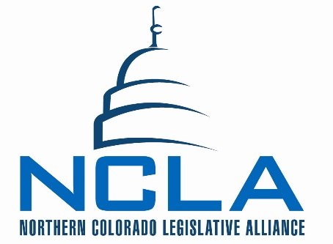
MINUTES

Board of Directors Meeting
April 28, 2016

7:30 a.m. – 9:00 a.m. Conference Call meeting

NCLA Chair – Laurel LaBonde

- Meeting called to order and quorum established by Chair LaBonde at 7:30am.
  - Quorum established at start of meeting.
  - Board attendance recorded on tracking worksheet.
  - Notes taken by Mindy McCloughan. Miller running NOCOM tradeshow.
  - Guests: Ann Hutchison, Fort Collins Area Chamber of Commerce.

Name | April 28th
May | Not present
Allard | x
Grant | Not present
Maxey | x
Tool | x
Waldo | Not present
MacQuiddy | x
Bright | x
Dennie | x
Jerke | x
LaBonde | x
Norton | x
Williams | x
McCloughan | x
Becker | San Antonio
Clark | x
Gazlay | x
Koelzer | x
McCambridge | Not participating in board
Olson | Not present
Werner | x
Montgomery | Not present
Solin | Called in to meeting
Miller | Not Present - NOCOM

- Consent agenda and financial report was approved as presented.

- Solin presented a legislative update and reported on the transportation project list.

- Bill Review:
  - HB16-1450 support in concept on a 1st Tom N. seconded by Kermit A.
  - HB16-1454 No position – no action taken
  - HB16-194 Monitor – 1st Tom N. seconded by Steve Tool

- Committee Updates:
  - Workers: NO report
  - Water: No Report
  - Energy: Sarah reported on the Energy proud luncheon on May 16th with limited seating
  - Transportation: Sandra reported the transportation commission approved additional 50 million for the corridor. Sandra also reported a construction defects bill still hasn’t dropped yet.

- Mtg. adjourned at 8:37am

